***Python Flask Tutorial for Begineers***

**from** flask **import** Flask  
  
app= Flask(__name__)  
  
@app.route(**'/'**)  
@app.route(**'/home/'**)  
**def** hello():  
 **return "Hello World"  
  
if** __name__==**"__main__"**:  
 app.run(debug=**True**)

<http://localhost:5000/>

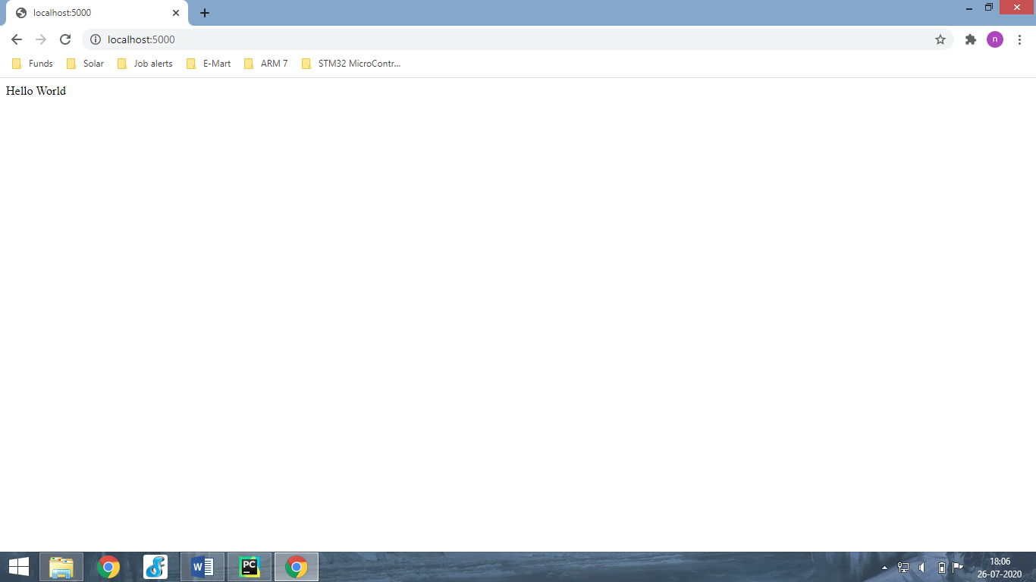

<http://localhost:5000/home/>

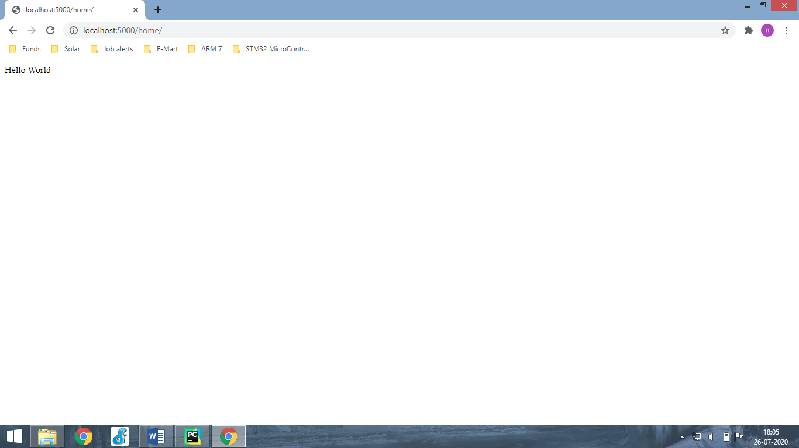

**Add String**

**from** flask **import** Flask  
  
app= Flask(__name__)  
  
@app.route(**'/home/<string:name>'**)  
**def** hello(name):  
 **return "Hello "**+name  
  
**if** __name__==**"__main__"**:  
 app.run(debug=**True**)

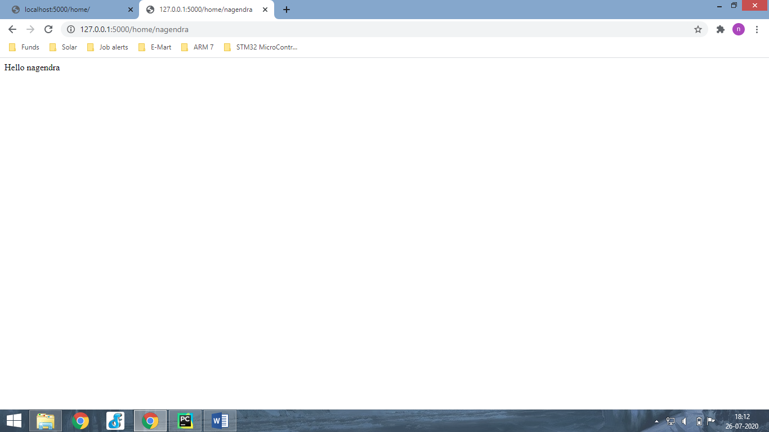

**from** flask **import** Flask  
  
app= Flask(__name__)  
  
@app.route(**'/'**)  
**def** startPage():  
 **return "Hello World "**@app.route(**'/home/<string:name>'**)  
**def** func1(name):  
 **return "Hello "**+name  
  
@app.route(**'/user/<int:id>'**)  
**def** func2(id):  
 **return "User "**+str(id)  
  
  
**if** __name__==**"__main__"**:  
 app.run(debug=**True**)

<http://127.0.0.1:5000/user/2>

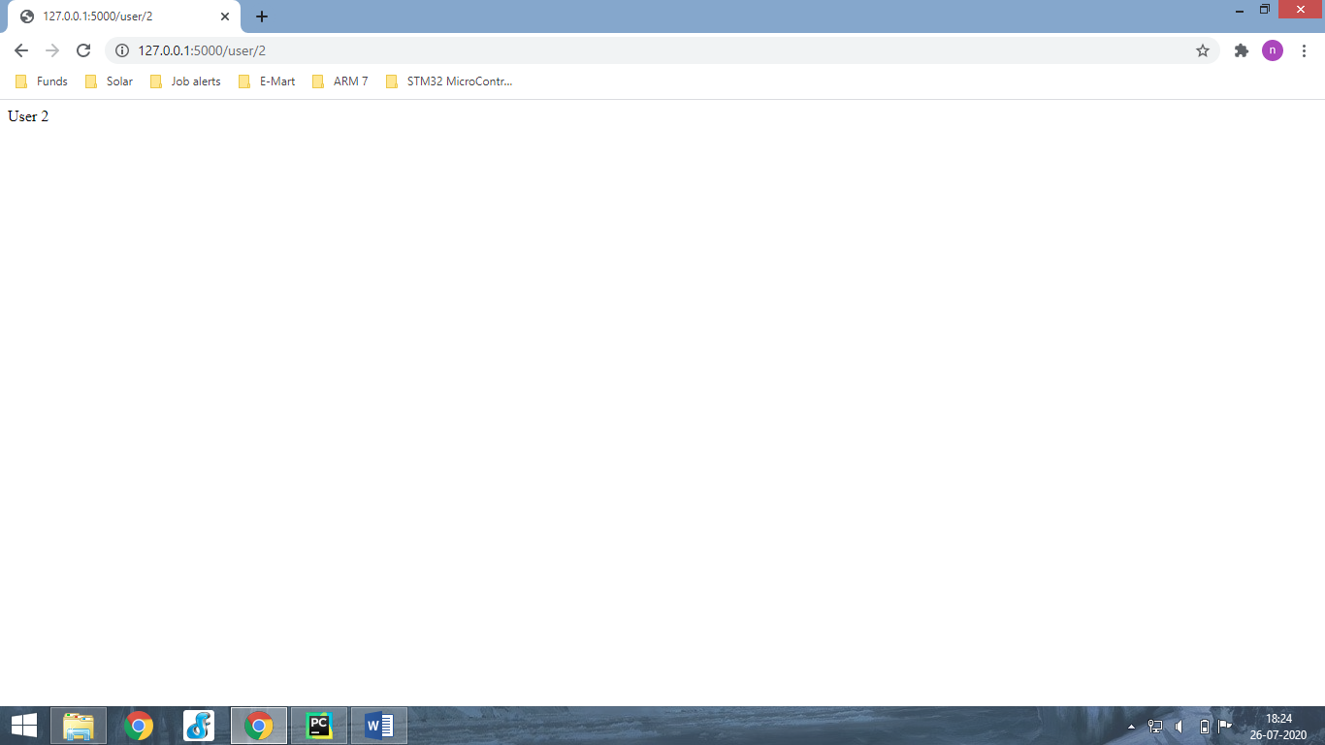

**from** flask **import** Flask  
  
app= Flask(__name__)  
  
@app.route(**'/'**)  
**def** startPage():  
 **return "Hello World "**@app.route(**'/home/users/<string:name>/posts/<int:id>'**)  
**def** func1(name,id):  
 **return "Hello "**+name+**", your id is: "**+str(id)  
  
**if** __name__==**"__main__"**:  
 app.run(debug=**True**)

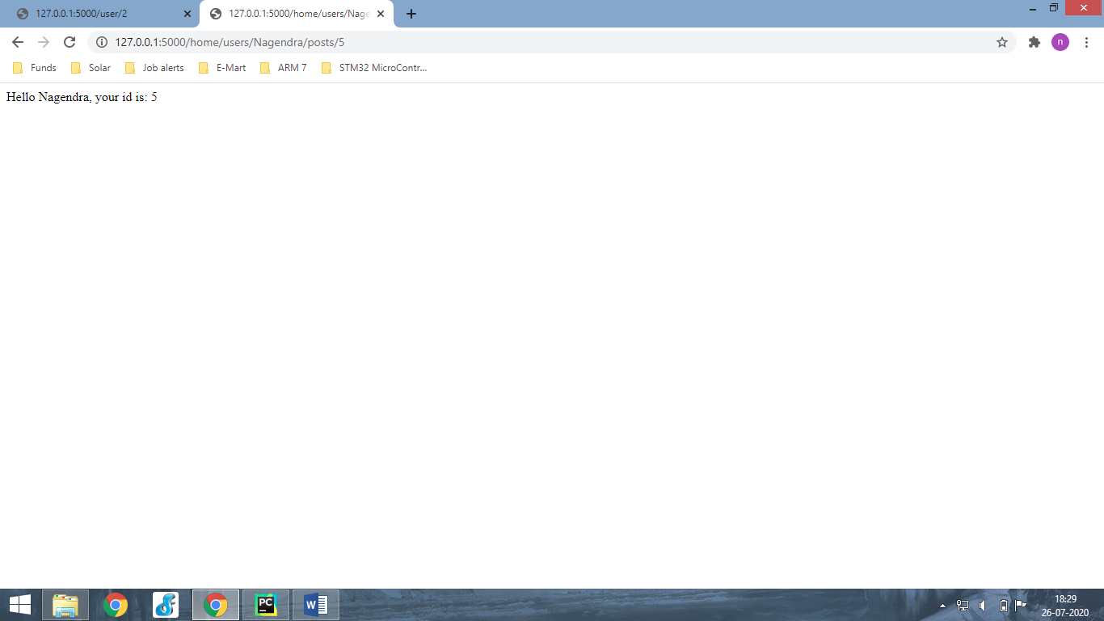

**from** flask **import** Flask  
  
app= Flask(__name__)  
  
@app.route(**'/'**)  
**def** startPage():  
 **return "Hello World "**@app.route(**'/home/users/<string:name>/posts/<int:id>'**)  
**def** func1(name,id):  
 **return "Hello "**+name+**", your id is: "**+str(id)  
  
@app.route(**'/onlyget'**)  
**def** get_req():  
 **return 'You can only get this webpage'  
  
if** __name__==**"__main__"**:  
 app.run(debug=**True**)

<http://127.0.0.1:5000/onlyget>

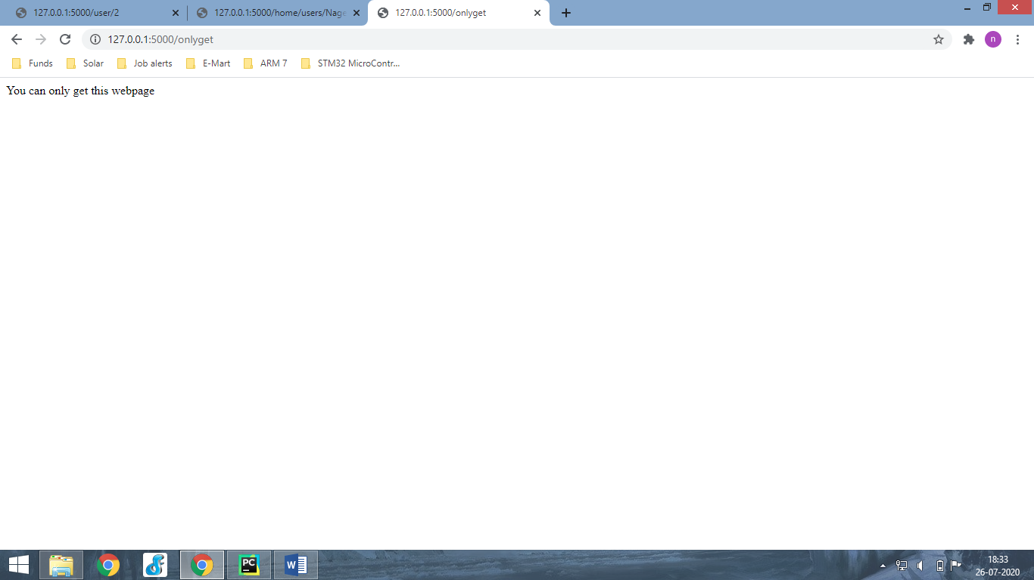

**from** flask **import** Flask  
  
app= Flask(__name__)  
  
@app.route(**'/'**)  
**def** index():  
 **return** \  
 **'''  
 <h1>Heading 1 </h1>  
 <h2>Heading 2 </h2>  
 '''**@app.route(**'/home/users/<string:name>/posts/<int:id>'**)  
**def** func1(name,id):  
 **return "Hello "**+name+**", your id is: "**+str(id)  
  
@app.route(**'/onlyget'**, methods=[**'GET'**])  
**def** get_req():  
 **return 'You can only get this webpage'  
  
if** __name__==**"__main__"**:  
 app.run(debug=**True**)

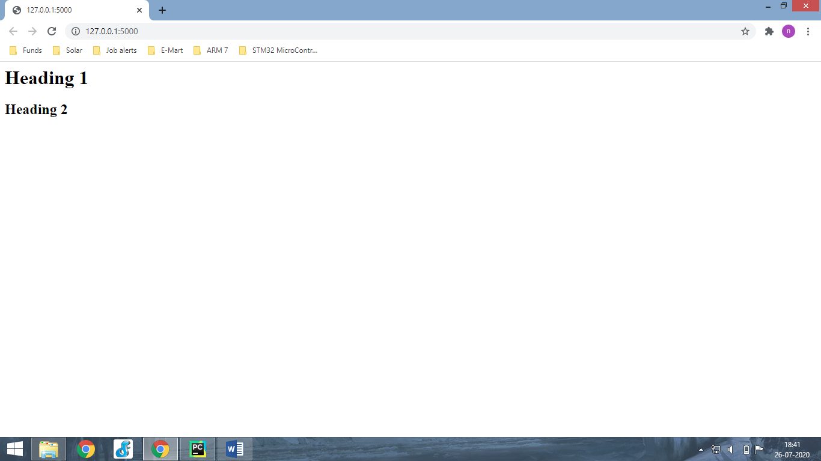

**from** flask **import** Flask  
  
app= Flask(__name__)  
  
@app.route(**'/'**)  
**def** index():  
 **return** \  
 **'''  
 <h1>Heading 1 </h1>  
 <h2>Heading 2 </h2>  
 '''**@app.route(**'/home/users/<string:name>/posts/<int:id>'**)  
**def** func1(name,id):  
 **return "Hello "**+name+**", your id is: "**+str(id)  
  
@app.route(**'/onlyget'**, methods=[**'GET'**])  
**def** get_req():  
 **return 'You can only get this webpage'**@app.route(**'/onlypost'**, methods=[**'POST'**])  
**def** post_req():  
 **return 'You can only post'  
  
if** __name__==**"__main__"**:  
 app.run(debug=**True**)

<http://127.0.0.1:5000/onlypost>

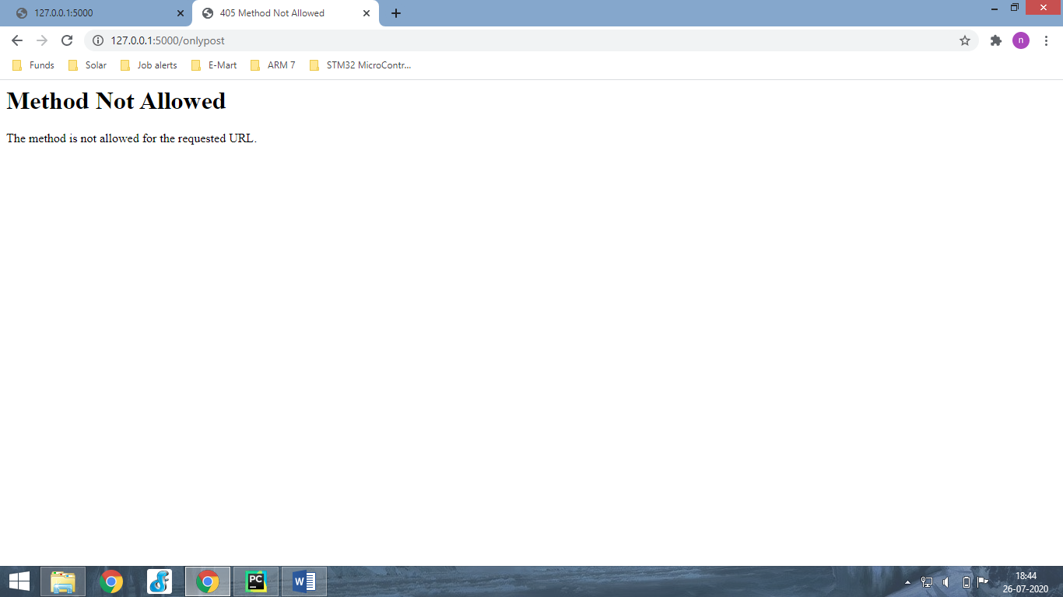

**from** flask **import** Flask  
  
app= Flask(__name__)  
  
@app.route(**'/'**)  
**def** index():  
 **return** \  
 **'''  
 <h1>Heading 1 </h1>  
 <h2>Heading 2 </h2>  
 '''**@app.route(**'/home/users/<string:name>/posts/<int:id>'**)  
**def** func1(name,id):  
 **return "Hello "**+name+**", your id is: "**+str(id)  
  
@app.route(**'/onlyget'**, methods=[**'GET'**])  
**def** get_req():  
 **return 'You can only get this webpage'**@app.route(**'/getpost'**, methods=[**'POST'**,**'GET'**])  
**def** get_post_req():  
 **return 'You can get and post by this.'**@app.route(**'/onlypost'**, methods=[**'POST'**])  
**def** post_req():  
 **return 'You can only post'  
  
if** __name__==**"__main__"**:  
 app.run(debug=**True**)

<http://127.0.0.1:5000/getpost>

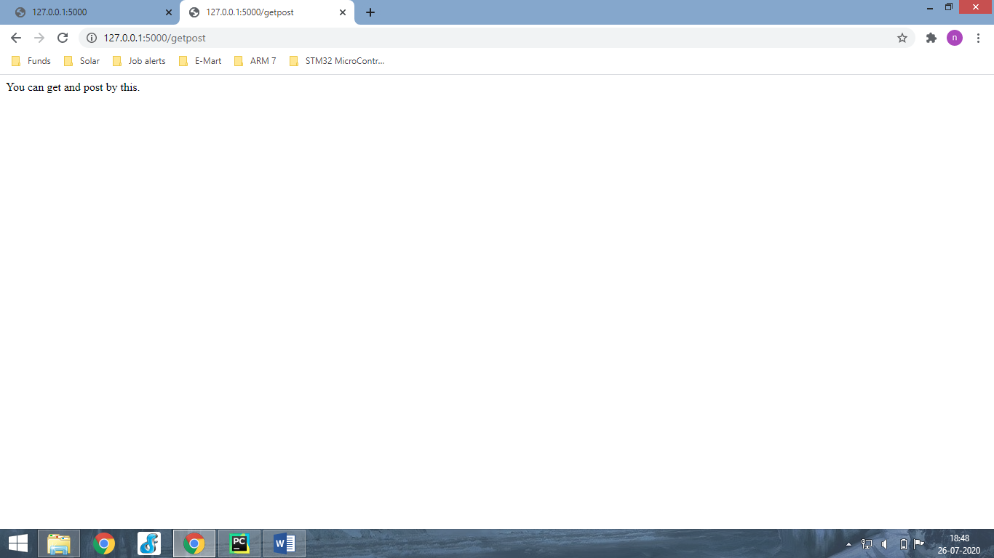

**from** flask **import** Flask, render_template  
  
app= Flask(__name__)  
  
@app.route(**'/'**)  
**def** index():  
 **return** render_template(**'index.html'**)  
  
@app.route(**'/posts'**)  
**def** posts():  
 **return** render_template(**'posts.html'**)  
  
  
**if** __name__==**"__main__"**:  
 app.run(debug=**True**)

|  |  |  |
| --- | --- | --- |
| base.html | index.html | posts.html |
| <!DOCTYPE html> <html lang="en"> <head>  <meta charset="UTF-8">  {% block head %} {% endblock %} </head> <body>  {% block body %} {% endblock %}  </body> </html> | {% extends 'base.html' %}  {% block head %} <**title**> Flask Website</**title**> {%endblock%}   {% block body %} <**h1**> Home Page</**h1**> {%endblock%} | {% extends 'base.html' %}  {% block head %} <**title**> Flask Website Posts </**title**> {%endblock%}  {% block body %} <**h1**>All Posts</**h1**> {%endblock%} |

<http://127.0.0.1:5000/posts>

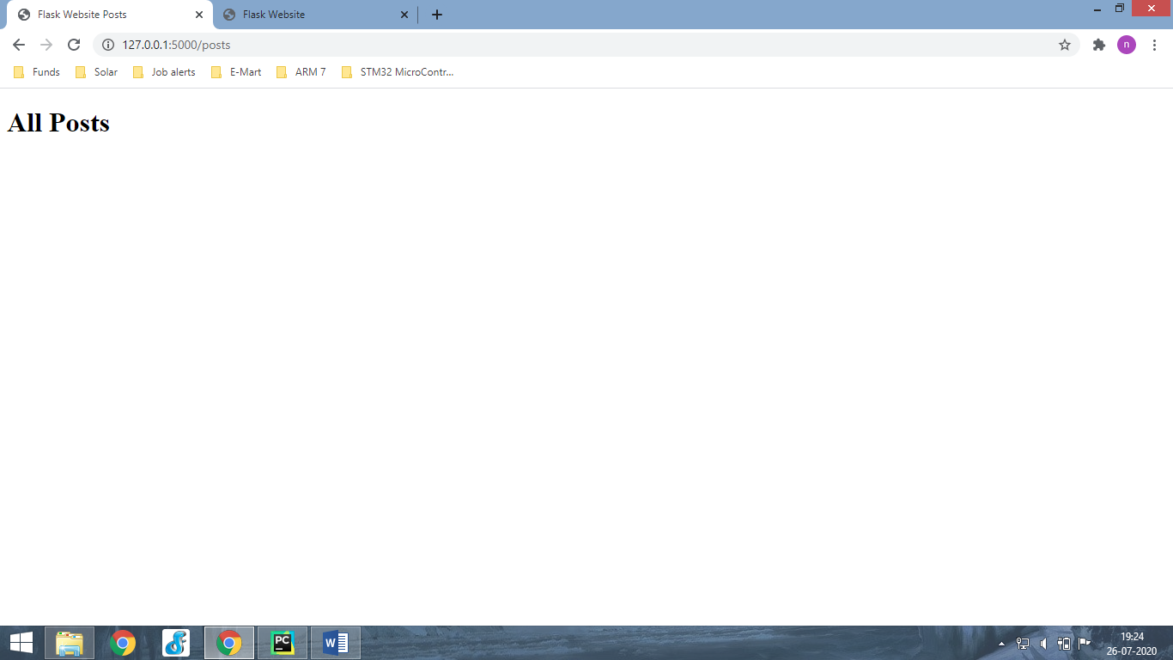

**from** flask **import** Flask, render_template  
  
app= Flask(__name__)  
  
all_posts=[  
 {  
 **'title'**:**'Post 1'**,  
 **'content'**:**'This is the content of post1. lalala'**,  
 **'Author'**:**'Nagendra'** },  
 {  
 **'title'**:**'Post 2'**,  
 **'content'**:**'This is the content of post2. lalala'** },  
]  
  
@app.route(**'/'**)  
**def** index():  
 **return** render_template(**'index.html'**)  
  
@app.route(**'/posts'**)  
**def** posts():  
 **return** render_template(**'posts.html'**,post=all_posts) *# post/anyname***if** __name__==**"__main__"**:  
 app.run(debug=**True**)

|  |
| --- |
| Posts.html |
| {% extends 'base.html' %}  {% block head %} <**title**> Flask Website Posts </**title**> {%endblock%}  {% block body %} <**h1**>All Posts</**h1**>   {% for x in post %}  <**h2**>{{x.title}}</**h2**>   {% if x.Author %}  <**h3**>By: {{x.Author}}</**h3**>  {% else %}  <**h3**>By: N/A </**h3**>   {% endif %}   <**p**>{{x.content}}</**p**>  {%endfor%} {%endblock%} |

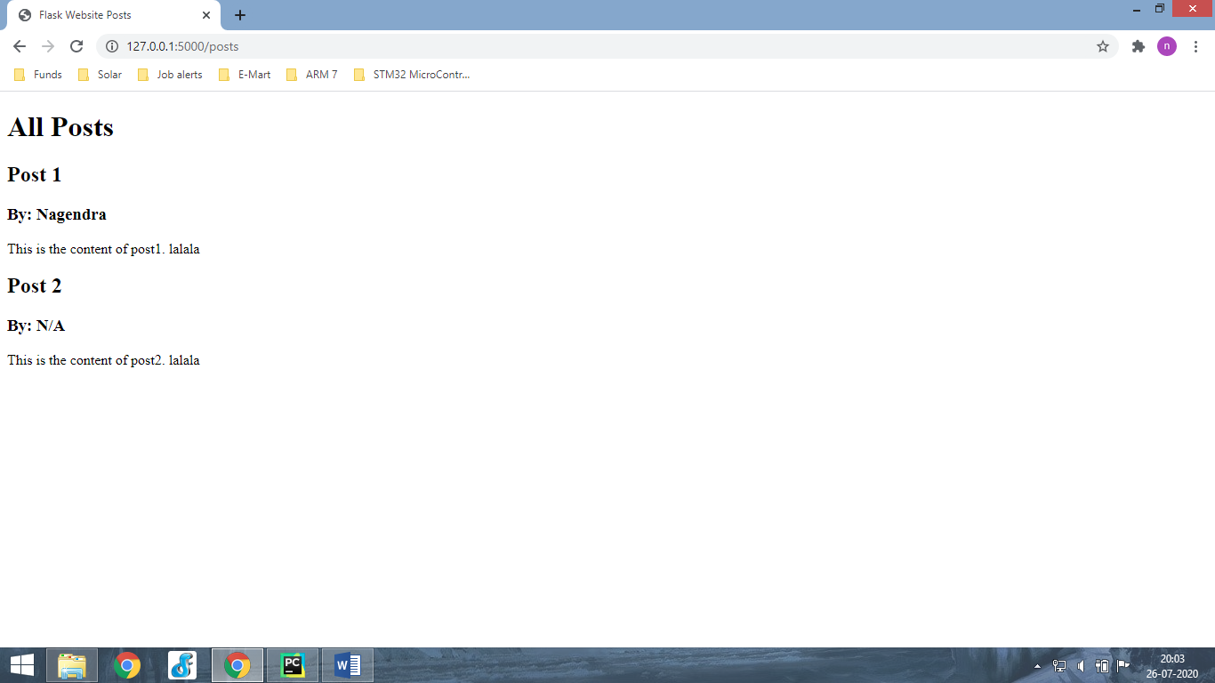

**from** flask **import** Flask, render_template  
  
app= Flask(__name__)  
  
all_posts=[  
 {  
 **'title'**:**'Post 1'**,  
 **'content'**:**'This is the content of post1. lalala'**,  
 **'Author'**:**'Nagendra'** },  
 {  
 **'title'**:**'Post 2'**,  
 **'content'**:**'This is the content of post2. lalala'** },  
 {  
 **'title'**:**'Post 3'**,  
 **'content'**:**'This is the content of post3. lalala'**,  
 },  
 {  
 **'title'**:**'Post 4'**,  
 **'content'**:**'This is the content of post4. lalala'**,  
 **'Author'**:**'Nagendra'** },  
 {  
 **'title'**:**'Post 5'**,  
 **'content'**:**'This is the content of post5. lalala'**,  
 **'Author'**:**'Nagendra'** }  
]  
  
@app.route(**'/'**)  
**def** index():  
 **return** render_template(**'index.html'**)  
  
@app.route(**'/posts'**)  
**def** posts():  
 **return** render_template(**'posts.html'**,post=all_posts) *# post/anyname***if** __name__==**"__main__"**:  
 app.run(debug=**True**)

|  |  |
| --- | --- |
| _main.css | _base.html |
| body {  margin: 0;  padding: 0;  font-family: "Helvetica Neue", Helvetica, Arial, sans-serif;  color: #060; }  */*  * Formatting the header area  */* header {  background-color: #DFB887;  height: 35px;  width: 100%;  opacity: .9;  margin-bottom: 10px; }  header h1.logo {  margin: 0;  font-size: 2.2em;  color: #fff;  text-transform: uppercase;  float: left; }  h2 {  font-size: 3em;  margin-top: 40px;  text-align: center;  letter-spacing: -2px; }  h3 {  font-size: 1.7em;  font-weight: 100;  margin-top: 30px;  text-align: center;  letter-spacing: -1px;  color: #999; } | <!DOCTYPE **html**> <**html lang="en"**> <**head**>  <**meta charset="UTF-8"**>  <**meta name="Description" content="This is good website"**>  <**meta name="author" content="Nagendra"**>  <**meta name="keywords" content="Flask Tutorials"**>  <**meta name="viewport" content="Width=device-width, initial-scale=1.0"**>  <**link rel="stylesheet" href="{{url_for('static',filename='css/main.css')}}"**>  *<!--  <link rel="stylesheet" href="static/css/main.css">  -->* {% block head %} {% endblock %} </**head**> <**body**>  {% block body %} {% endblock %}  </**body**> </**html**> |

<http://127.0.0.1:5000/>

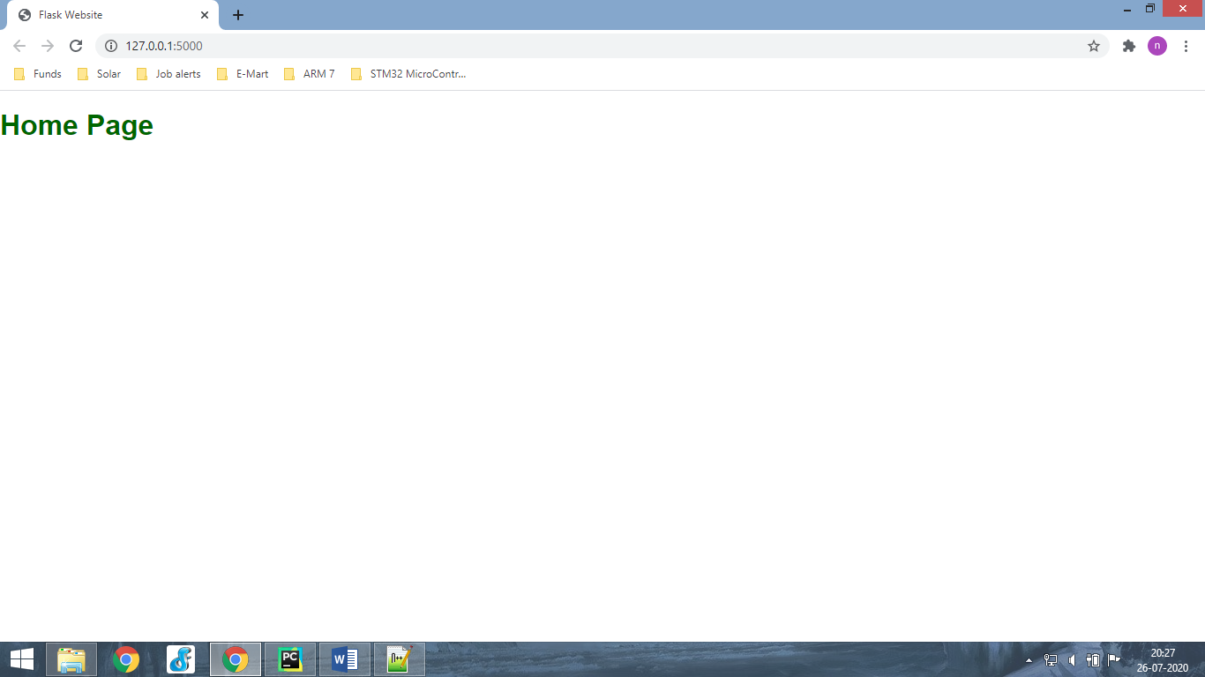

<http://127.0.0.1:5000/posts>

